Experiment - 5
Operating Systems Lab
Syeda Reeha Quasar
14114802719
6C7
AIM
Write a program for page replacement policy using:
a) LRU b) FIFO c) Optimal.

EXPERIMENT – 5

Aim:
Write a program for page replacement policy using:
- LRU
- FIFO
- Optimal

Theory:
The page replacement algorithm decides which memory page is to be replaced. The process of replacement is sometimes called swap out or write to disk. Page replacement is done when the requested page is not found in the main memory (page fault). There are various page replacement algorithms. Each algorithm has a different method by which the pages can be replaced.
- Least recent used (LRU) page replacement algorithm → this algorithm replaces the page which has not been referred to for a long time. This algorithm is just the opposite to the optimal page replacement algorithm. In this, we look at the past instead of staring at the future.
- First In First Out (FIFO) page replacement algorithm → in this algorithm, a queue is maintained. The page which is assigned the frame first will be replaced first. In other words, the page which resides at the rare end of the queue will be replaced on every page fault.
- Optimal Page Replacement algorithm → this algorithm replaces the page which will not be referred to for so long in the future. Although it cannot be practically implementable it can be used as a benchmark. Other algorithms are compared to this in terms of optimality.

Source Code:

LRU (Least Recently Used) page replacement algorithm

#!/bin/bash
pages=(7 0 1 2 0 3 0 4 2 3 0 3 2)
capacity=4
count=0
fault=0
n=13
echo "frame1 frame2 frame3 frame4"
declare -a frames
declare -a time
i=0
while [ $i -lt $capacity ]
do
frames[$i]=-1
i=$((i+1))
done
j=0
while [ $j -lt $n ]
do
flag1=0
flag2=0
k=0
while [ $k -lt $capacity ]
do
if [ ${frames[$k]} -eq ${pages[$j]} ]
then
count=$((count+1))
time[$j]=$count
flag1=1
flag2=1
break
fi
k=$((k+1))
done
if [ $flag1 -eq 0 ]
then
a=0
while [ $a -lt $capacity ]
do
if [ ${frames[$a]} -eq -1 ]
then
count=$((count+1))
fault=$((fault+1))
frames[$a]=${pages[$j]}
time[$a]=$count
flag2=1
break
fi
a=$((a+1))
done
fi
if [ $flag2 -eq 0 ]
then
pos=0
minimum=${time[0]}
b=1
while [ $b -lt $capacity ]
do
if [ ${time[$b]} -lt $minimum ]
then
minimum=${time[$b]}
pos=$b
fi
b=$((b+1))
done
count=$((count+1))
fault=$((fault+1))
frames[$pos]=${pages[$j]}
time[$pos]=$count
fi
echo ${frames[0]} " " ${frames[1]} " " ${frames[2]} " " ${frames[3]}
j=$((j+1))
done
echo "Total page faults = 6"

Output:

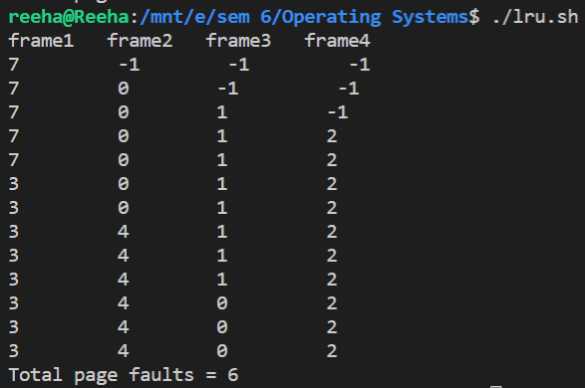

FIFO (First In First Out) page replacement algorithm

pages=(7 0 1 2 0 3 0 4 2 3 0 3 2)
capacity=4
count=0
fault=0
n=13
echo "frame1 frame2 frame3 frame4"
declare -a frames
i=0
while [ $i -lt $capacity ]
do
frames[$i]=-1
i=$((i+1))
done
j=0
while [ $j -lt $n ]
do
flag=0
k=0
while [ $k -lt $capacity ]
do
if [ ${frames[$k]} -eq ${pages[$j]} ]
then
flag=1
fault=$((fault-1))
fi
k=$((k+1))
done
fault=$((fault+1))
if [ $fault -le $capacity ] && [ $flag -eq 0 ]
then
frames[$j]=${pages[$j]}
else if [ $flag -eq 0 ]
then
frames[$(( (fault-1)%capacity))]=${pages[$j]}
fi
fi
echo ${frames[0]} " " ${frames[1]} " " ${frames[2]} " " ${frames[3]}
j=$((j+1))
done
echo "Total page faults = " $fault

Output:

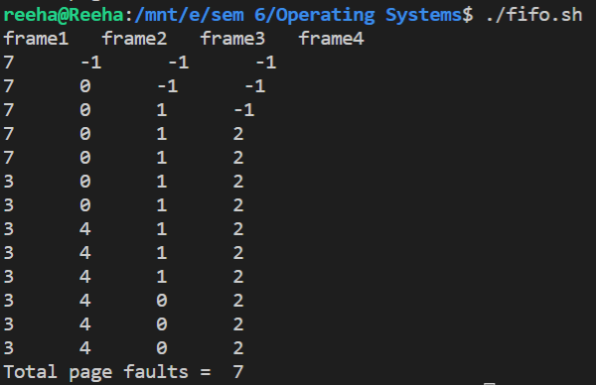
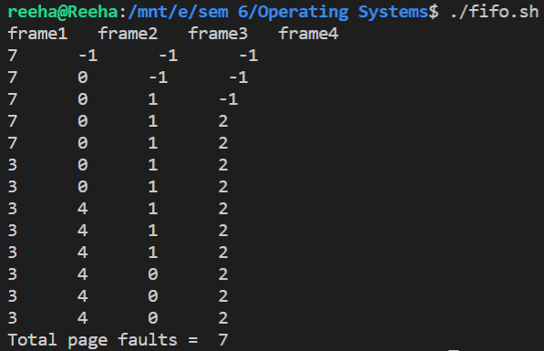

Optimal page replacement algorithm

pages=(7 0 1 2 0 3 0 4 2 3 0 3 2)
capacity=4
fault=0
n=13
declare -a frames
declare -a temp i=0
echo "frame1 frame2 frame3 frame4"
while [ $i -lt $capacity ]
do
frames[$i]=-1
i=$((i+1))
done
j=0
while [ $j -lt $n ]
do
flag1=0
flag2=0
k=0
while [ $k -lt $capacity ]
do
if [ ${frames[$k]} -eq ${pages[$j]} ]
then
flag1=1
flag2=1
break
fi
k=$((k+1))
done
if [ $flag1 -eq 0 ]
then
a=0
while [ $a -lt $capacity ]
do
if [ ${frames[$a]} -eq -1 ]
then
fault=$((fault+1))
frames[$a]=${pages[$j]}
flag2=1
break
fi
a=$((a+1))
done
fi
if [ $flag2 -eq 0 ]
then
flag3=0
x=0
while [ $x -lt $capacity ]
do
temp[$x]=-1
y=$((j+1))
while [ $y -lt $n ]
do
if [ ${frames[$x]} -eq ${pages[$y]} ]
then
temp[$x]=$y
break
fi
y=$((y+1))
done
x=$((x+1))
done
z=0
while [ $z -lt $capacity ]
do
if [ ${temp[z]} -eq -1 ]
then
pos=$z flag3=1
break
fi
z=$((z+1))
done
if [ $flag3 -eq 0 ]
then
maximum=${temp[0]}
pos=0
w=0
while [ $w -lt $capacity ]
do
if [ ${temp[$w]} -gt $maximum ]
then
maximum=${temp[$w]}
pos=$w
fi
w=$((w+1))
done
fi
frames[$pos]=${pages[$j]}
fault=$((fault+1))
fi
echo ${frames[0]} " " ${frames[1]} " " ${frames[2]} " " ${frames[3]}
j=$((j+1))
done
echo "Total page faults = " $fault

Output:

